9.84: Taking the zero of gravitational potential energy to be at the axle, the initial potential energy is zero (the rope is wrapped in a circle with center on the axle).When the rope has unwound, its center of mass is a distance 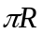below the axle, since the length of the rope is 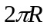and half this distance is the position of the center of the mass. Initially, every part of the rope is moving with speed 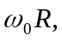 and when the rope has unwound, and the cylinder has angular speed 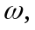the speed of the rope is 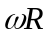(the upper end of the rope has the same tangential speed at the edge of the cylinder). From conservation of energy, using 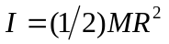for a uniform cylinder,
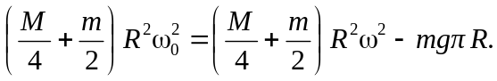
Solving for gives
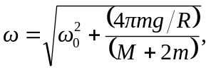

and the speed of any part of the rope is 